GP attitudes and practices relating to the provision of medical evidence as part of the Employment and Support Allowance (ESA) claim process

Background
CAB advisers know it’s more likely the Department for Work and Pensions (DWP) will make the right decision on whether someone is fit for work if substantial medical evidence is collected on an ESA claim. However, this evidence is not always requested as standard by the DWP or Atos for each new claim. Where it is, it can be as basic as a copy of claimant medical records that may not highlight mental health issues or learning disabilities and may underestimate the impact of illness or disability on someone’s ability to work.

Throughout the application process, claimants are encouraged to send in additional evidence from the health and social care professional that knows them best. There is, however, no requirement on GPs or other professionals to provide this information when it is requested by a patient. Some refuse to provide evidence while others charge people up to £125 for the medical evidence requested. This survey was carried out in order to examine the extent of this issue.

Methodology
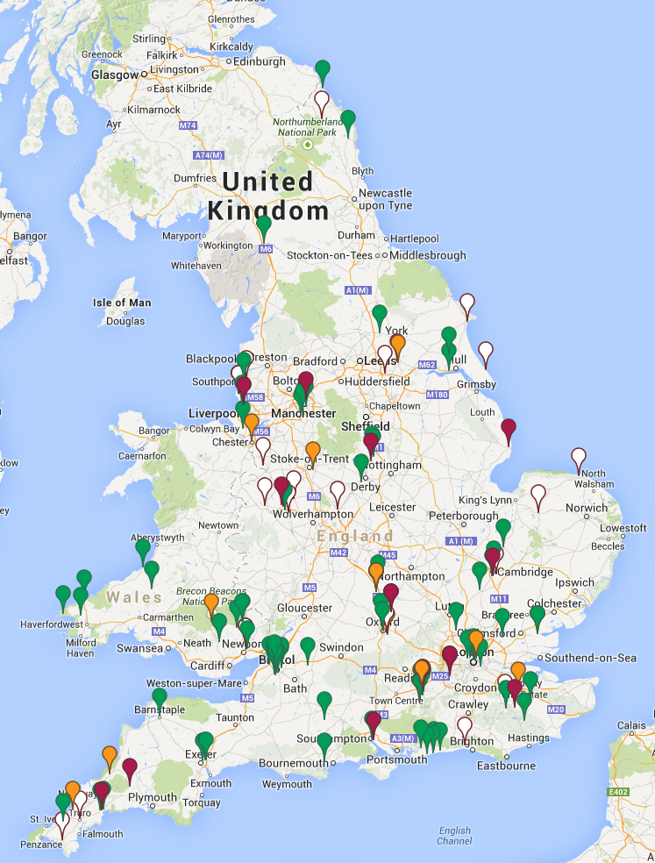
Surveys were sent out in paper and digital formats throughout March and April 2014 by around 70 bureaux. All GPs in each area were targeted either directly or via a Clinical Commissioning Group or Local Medical Committee, with a letter explaining the purpose of the survey and a copy of the survey itself. Response rates were respectable but not high – ranging from 20-50 per cent of those targeted. In total, 173 GP practices responded.

Coverage
The map on the right indicates the locations of surveyed GPs. It is colour coded by overall willingness to provide medical evidence. These surgeries ranged from individual GPs (6 per cent) to multi-GP practices of more than five members (41 per cent). In total they recorded a combined patient coverage of 1,258,564 people – an average of almost 9,000 per practice.

Providing evidence

29 per cent of respondents did not provide medical evidence as standard to all patients. The primary reasons given for declining some or all requests were ‘lack of time’ and ‘don’t feel it is my job’.

We asked: Please outline your reasons for declining requests for medical evidence from patients:
- Very time consuming and no funding for service – not covered by NHS.
- We already work 13 hour days. We have already filled out the DWP forms, sick notes etc. To have to do it all over again to support a claim is ridiculous. Even if we charge for this service, we simply DO NOT have time. We've already provided the information.

Charges

Our findings suggested that while only 15 per cent of GPs refused to provide evidence, over 70 per cent of those who would provide evidence charged for it in some or all cases. We also found that 47 per cent of respondents indicated that the practice played a key role in determining access to medical evidence – demonstrating a lack of consistency and the creation of a possible ‘postcode lottery’ in access to evidence.

We asked: If you provide medical evidence for free to ‘some groups of patients’ and charge others, please outline your criteria for making this decision:
- We provide a basic print out of patient history and medication on request for no fee. We consider, but advise against the patient seeking additional or factual information for a nominal fee. We can only recover for a fee if required. In exceptional circumstances we provide additional information pro bono.
- The work is not NHS required we do not charge where we consider someone cannot currently afford to pay and would waive the standard fee.
- If we provide a general print out (electronic) from the patient’s notes , which outlines their ‘active’ problems, we do not charge. If a doctor has to write a letter, we generally charge.
- The charge is for more detailed medical evidence. The evidence is provided when the patient is worth supporting.
- It might vary depending on the GPs relationship with the individual patient, perceived need, etc. It also might depend on how easy it is to provide the information. A straightforward summary print out of electronic records can be produced with a few key strokes. The actual admin of invoicing would probably take longer! An ‘opinion’ will clearly take longer and may mean dictating/transcribing a reply.

We asked: If you provide medical evidence for free to ‘some groups of patients’ and charge others, please outline your reasons for this:
- We face (increased) requests for non-funded, non-NHS work and have to practise patient care over this discretionary work.
- We believe that having a doctor’s note counts for little, so our letters are a gesture usually – short and factual, bearing in mind we do not live with these patients.
- Doctors don’t like talking about money Expectation from patients is that this is free and a normal part of GP workload.
- We do not wish to disadvantage vulnerable patients but do feel that work undertaken by GPs should be remunerated.

We asked: Please outline your reasons for setting this fee:
- These fees are set by the partners using national guidance, research of local markets and analysis of practice GP and administrative costs.
- Photocopying costs – can be waived depending on size and situation.
- Time-consuming for staff.
- It’s private work – paper, scanner, toner, admin work. Half the time, they're not collected from reception. If CAB ask for it, It’s free. Or BMA rates are used.
- Cost of materials and time to do this adds to practice pressures actually seeing patients.
- We regret having to charge patients who can least afford it any fee at all. The fee is to provide a disincentive to request information that is not really required.
- Reflective of the time taken to assemble requested information, usually in the form of a meaningful and useful letter.
- £15 – £25, depending on the time taken for fixed costs and our time (stationery, printing etc).
- This is a non-NHS service. The number raised is a significant burden on the time of clinical and non-clinical staff. Also by setting a fee, only people who really want to request. If free I would expect the number to quadruple!
- Related to the amount of work involved.
- It is not GMS work. It takes time, GP and secretarial, and the GP is taking responsibility for a statement they may have to defend in court. We usually charge £20. This is a bargain for some reports as they are often long and complex.
- Because we don't want to do this work. It is not NHS care. We have already provided the information and, yes, we do think quite a lot of the patients should be going to work.
- £15 – £25 depending on time taken for ... costs and out-time cost – stationary, printing.
- Patients generally request a professional opinion rather than just factual medical details. This is a private matter not funded by the NHS and as such we charge a fee to cover our time.
- We get many requests for information which is not always required by a third party – we charge the fee for our time and administration of the task and to ensure that patients are committed to wanting this evidence.

Types of evidence

Demand
The survey examined the breakdown of requests for medical evidence around ESA received by GPs over the past 12 months. These questions looked at the level of data collected by GPs on demand and whether the majority of evidence requests were made by the DWP or by claimants themselves. An average of 45 per cent of respondents did not hold information on these requests.

GP contracts mean they are obliged to provide evidence when requested by DWP but not when it is requested by a patient.

Medical evidence policies
Only 24 per cent of GP surgeries surveyed had an agreed, written policy on the provision of medical evidence to patients as part of the ESA Work Capability Assessment (WCA) process. Whether part of an agreed policy or not, GPs suggested that individual practices are the key decision-makers in determining if and how evidence is to be provided. There is little consensus around other stakeholders with the power to determine guidelines for medical evidence provision.

We asked: Are there any changes to the system you would recommend which would make it easier for you to provide medical evidence free of charge to the client?

- We object to the fact that outside agencies request the information, yet pass the responsibility for deciding whether to charge an individual or not onto the practice. This should be done at the point of origin. The outside agency requiring the information needs to pay. Gone are the days when this information can be provided for free. Primary care budgets have been cut significantly already and there is a necessity to make an appropriate charge for providing the service, in order to balance our books. However, the current system adopted by BCC is that they make it a practice decision whether or not to pass the cost for the information they require onto the patient – that is inherently wrong.
- Standard ESA forms are easier to process compared to patients requests for letters and supporting evidence
- Simplify it – use of print out medical records would save time.
- Payment would need to be made by another source.
- Bypass the need altogether as have already submitted the information once and only done due to patient pressure, often from organisations such as CAB.
- There is no such thing as free of charge – someone pays for the time and admin costs. Free for the patient would need reimbursement from another source. If providing sick notes that should be medical evidence enough.
- In my 25+ years of experience as a GP most requests for additional medical evidence are 'spurious claims' and would take up too many unnecessary appointment times and GP time, costing the NHS a six figure number easily, and another example of 'waste' in the NHS. Medical evidence is already supplied on the ESA. The assessment *must* be free of GP bias. This view is strongly shared by the BMA, LMC, Health boards, and the majority of GPs in this country – we can't all be wrong!
- Whole system needs review – practice unconvinced that medical information is helpful in assessing (previously provided in standard format as part of contract).
- All requests take staff time and have a cost to the practice it could be funded by the Government.
- In line with BMA guidelines – to cover GP time/administration/postage costs as activity is non-NHS funded.
- To cover admin time. Also to try and discourage requests. We tell patients to get Atos to write to us directly.
- Providing copies of medical records – which can end up being 100s of pages free of charge is not a viable option considering the time it will take for a GP or receptionist to collate and print the notes. The GP to check through the notes and sign to say they are happy and then post them recorded delivery. Everything that is done incurs a cost and free of charge is not an option in this day and age where costs are rising on an almost weekly basis.
- To be funded from another source to undertake the work.
- Provide more hours in the day!
- Current guidelines.
- Guidance of exactly what the department would find useful to know from me to best support my patient.
- Less requests for information from any source – verbal requests by patients being told by appeal process/Jobcentre to get a further report when often two have already been sent on official forms.
- No. Who else works for free? Will Tesco or British Gas give them a discount? Does your CEO not get paid? I think it's wholly inappropriate to apply pressure on GPs to work for free.
- Yes if bosuied such as yourself actually read the cabinet office guidance " patients Not Paperwork" which instructs of your and the patient duties in this matter- which odes include NOPT approaching GP@s directly. The information you require could be obtained from Seftomn Local Medical Committee , so you are gain on breach of your obligation on this matter.
- Third party should provide copies of 'points scored for each section' by Atos.
- We do not charge as such for a print out of medical records but would consider a charge for a written report. However a fee to the GP would be fair, after already having completed a report for the DWP.
- Would like to see the onus on the DWP to pay. Would prefer not to charge patients, but as the practice is located in a deprived area they are inundated with requests for medical evidence to support benefit claims and appeals (incl. housing). Funding cuts to practices in deprived areas have reduced the ability of doctors to spend time on this kind of work. Can only see the charges going up in the future as demand is so high. Free provision is impossible due to the workload.
- Would like to see a standard letter from the DWP, paid for by the DWP. Is very unhappy that GPs’ time is taken up for free. It is unfair that patients are required to obtain their own evidence.
- The system is wrong in that patients have to seek out their own evidence from GPs. The provision of supporting evidence for benefits is a major problem for the health service. GPs would rather focus on clinical care and services. Patients should not have to seek out their own evidence. This should be dealt with via another organisation/body.
- A specific form detailing exact requirements, rather than patients asking for all of their records each time.
- Need for evidence should be fully funded and should not require patients to request this evidence.
- The more deprived the area the more requests for medical evidence are needed. This takes more of our time when we are already busy with more illness due to deprivation and we feel we cannot charge pt for these type of letters. a recognition of this dilemma would be helpful from all directions – CAB , DWP BMA . We and similar would not want to charge the patients but practices in deprived areas should be compensated in time or money to recognise additional time needed to do these things.
- Send it to someone else. We really really don't have time or energy to do them. There has been a vertical take off of requests. Investment in primary care has decreased as a percentage of the total NHS budget over the last 8 years. 90 per cent of patient contacts are in primary care. Over the last six years there were 40 million extra consultations per year with GPs in England. There aren't any more GPs, practice staff or time. We don't want to receive these forms/admin at all, ever. Suggest independent occupational health doctor paid for by Atos profits?
- It would be much easier if a standard printout of medical records, similar to an amount of work.
- CAB do the work and ask me to countersign that I agree with what has been said – if I do, I do! and don't charge.
- GPs should be asked by DWP for background medical information on all claimants as many claimants are not fully aware of all the conditions they have or their significance. I have seen patients' self-completed forms and they often understate their case by missing out important information. This is especially true of people with mental health problems, or people whose first language is not English.
- DWP should pay us.
- If CAB gave clients a form or an electronic link to a form to complete saying that 'you may charge the patient but most practices are prepared to fill this out for free'.
- Standard form with descriptors described would help. Brief [four sides A4 maximum] – one side better – description of key points for GPs to know.
- It is unlikely we would provide information beyond the ESA113 form free of charge. It is not unreasonable that we should be paid for our time for matters that are not direct healthcare. We are not familiar with the criteria used for assessing benefits entitlement and our input should be restricted to providing factual information about the medical conditions. We are often asked to provide information about a patient's activities of daily living in relation to benefits assessment but often do not know and simply invite the patient in to answer the questions. Accepting the patient's answer would be a way of avoiding any fees from the GP who is really only providing a signature to the patient's own opinion.

Green = provide medical evidence, amber = provide medical evidence to some groups, red = do not provide medical evidence.

